Bucket versioning

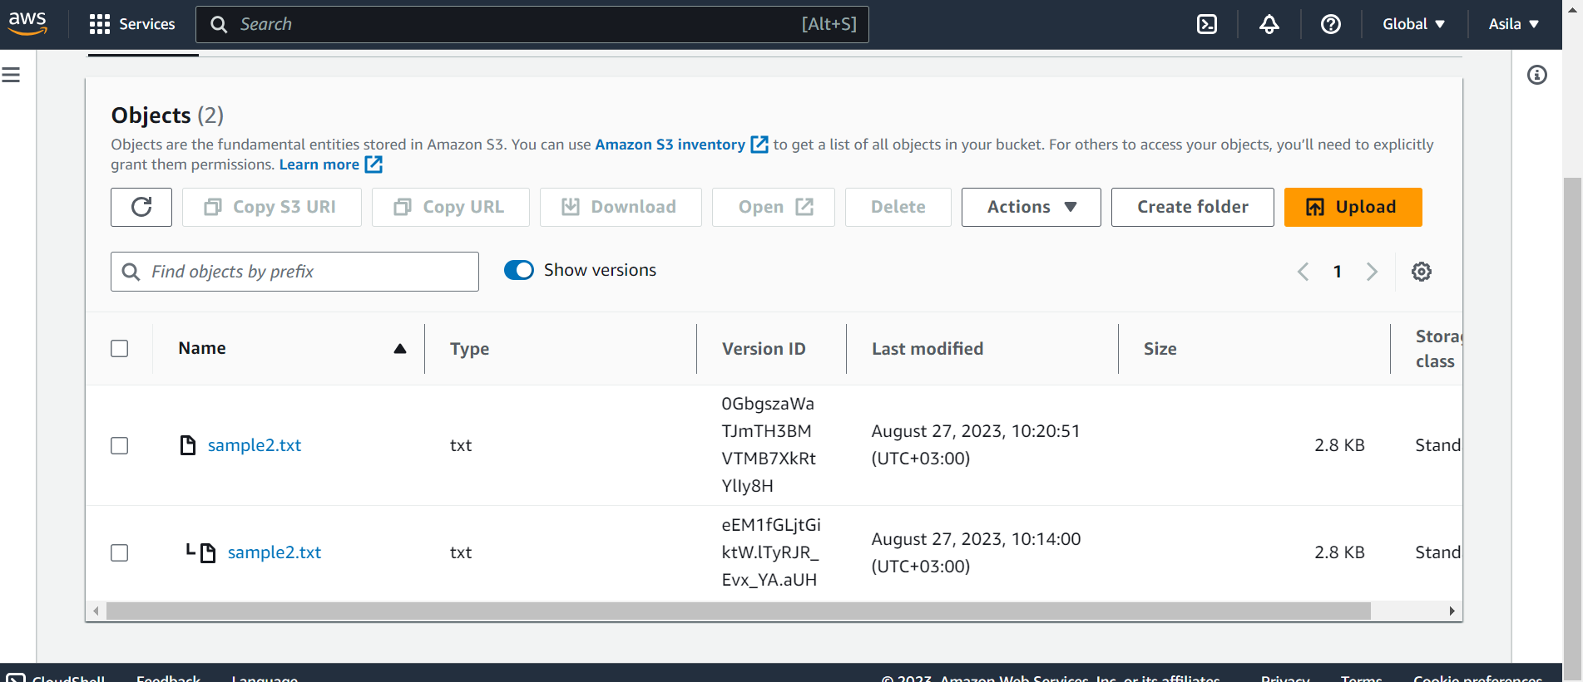

Bucket policy

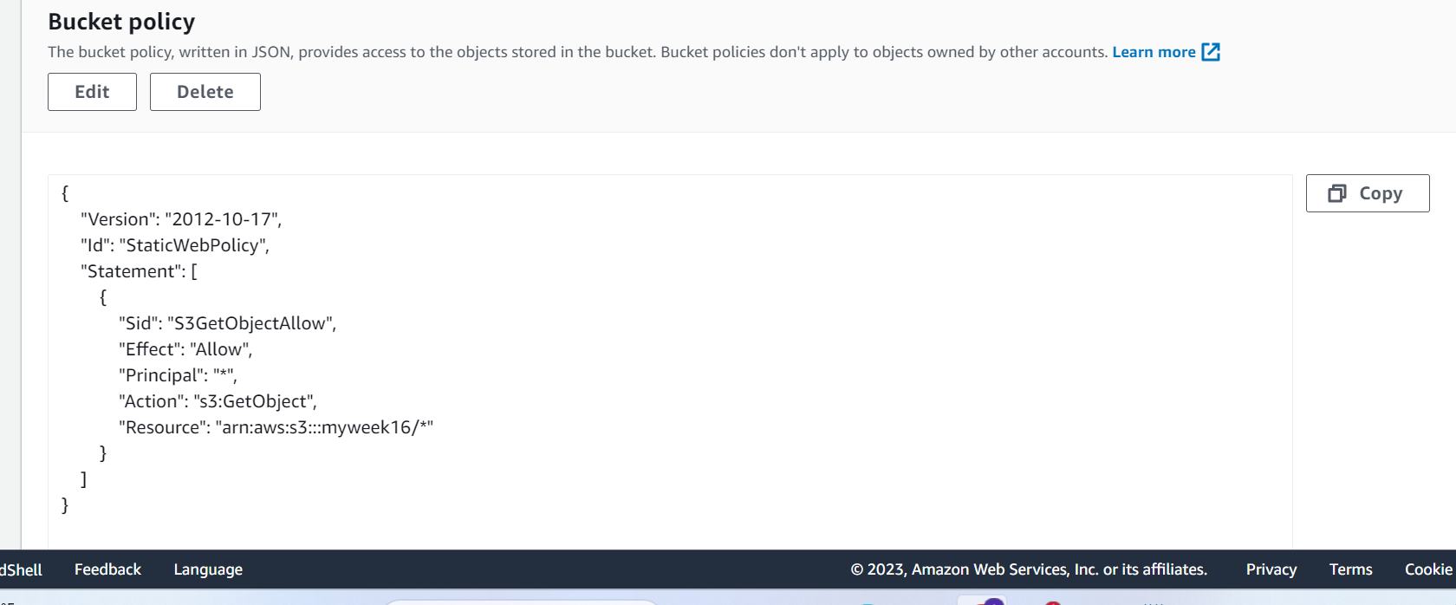

Obect url : <https://myweek16.s3.amazonaws.com/index.html>

Bucket publicly accessible

